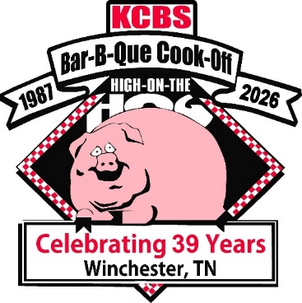
Dear Backyard Barbecue Cook Teams:
The Winchester, Tennessee High on the Hog BBQ Festival, The Kiwanis Club of Franklin County, TN, The City of Winchester, TN, The Herald Chronicle and our Local Sponsors are inviting you and your team to help us celebrate our 39th year on May 15-16, 2026. Your participation is vital to make this the best contest ever and we’d greatly appreciate your participation in the ancillaries, so that we can maintain our relationship with our sponsors in the future.
Please note on the application, the entry fee includes ALL Categories: Chicken and Ribs, Pork, Creative Sliders, Wampler’s Creative Tacos and Desserts. The Creative Sliders and Wampler’s Creative Tacos contest is on Friday Night. On Saturday, turn-in starts at 12noon with Chicken, followed by Ribs, then Pork and at 1:30p the Dessert turn-in. Meat inspection will begin on Friday morning as teams arrive to the cooking area and hopefully be completed by the time of the Cooks meeting, which will be at 4pm in the Red Roof Pavilion.
Any Team that has won or placed in the top five (5) of any Sanctioned KCBS BBQ Contest, (4 Meat Categories) in the past 2 years, Will Not be eligible for the Backyard Division and the Contest Organizer will make the final decision on this matter.
The cooking area does provide individual power and water and you’ll be responsible for hooking up your own power and water. Someone will be onsite as you arrive to show you and help you get parked.
NO early arrivals as far as setting up, the earliest arrival time is Friday at 8am. Friday and Saturday night entertainment is to be determined. Also, The Carnival will be onsite, from Wednesday, May 13th-Sunday 17th. We are looking forward to the 2026, 39th High on the Hog BBQ Festival, Tennessee State Championship. If there is anything we can do to make your participation a first-class experience, please let us know. Without you, there is no contest. We look forward to seeing you and your team on May 15, 2025.
Thanks,
Nancy Hibler, PO Box 461, Winchester, TN 37398, nancyh927@comcast.net 931-636-2719
Brenda Long, brendasuelong@hotmail.com or www.highonthehogfestival.com 931-607-7879

