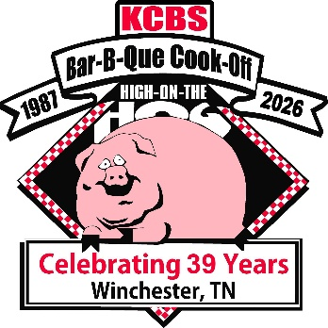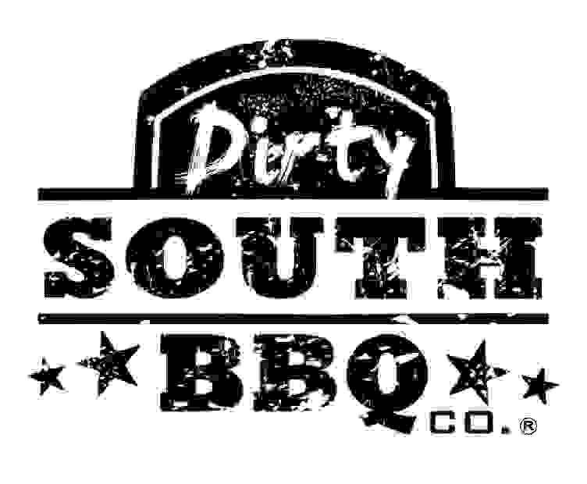
High on the Hog BBQ Festival Kid’s Q
May 16, 2026
Prizes Guaranteed
Trophies & Gift Card for 1st place in age groups 5-9 and 10-14
All Participants will receive a Medallion including the age group 2-4
Contest Located at the Winchester City Park, 1561 Phillip Fulmer Pkwy, Winchester, TN 37398
Please send or email Application by May 9th to: nancyh927@comcast.net 931-636-2719
Nancy Hibler, Chairperson, PO Box 461, Winchester, TN 37398
KIDS COOK TEAM NAME___________________________________________T-SHIRT SIZE____
COOK NAME (kids name)___________________________________________
CONTACT NAME__________________________________________________
CONTACT PHONE #___________________________EMAIL______________________________
AGE GROUP: AGES 2-4_____ AGE 5-9_____ AGE 10-14______
CONTEST DATE & TIME TO PARTICIPATE: SATURDAY, MAY 16, 2026. TURN-IN TIME 2:00PM NO CHARGE FOR PARTICIPANTS
SIGNATURE__________________________________________DATE______________________
AS THE PARENT OF___________________________________ I DO HEREBY GIVE MY PERISSION FOR MY CHILD TO PARTICIPATE IN THE HIGH ON THE HOG KID’S Q ON MAY 16, 2026. I AGREE ON BEHALF OF MYSELF, MY CHILD NAMED HEREIN TO HOLD HARMLESS AND DEFEND THE ORGANIZER, KIWANIS CLUB OF FRANKIN COUNTY, KIWANIS INTERNATIONAL, KY-TN DISTRICT AND ANY OTHER REPRESENTATIVES ASSOCIATED WITH THIS EVENT, FROM ANY AND ALL ACTIONS, CLAIMS, DAMAGES, COSTS, EXPENSES IN CONNECTION WITH MY CHILD ATTENDING THIS EVENT OR IN CONNECTION WITH ANY ILLNESS OR INJURY OR COST OF MEDICAL TREATMENT IN CONNECTION THEREIN.

HIGH ON THE HOG KID’S Q
MAY 16, 2026
AGE GROUPS

AGES 2-4:
MYSTERY BOX (PROVIDED) INGREDIENTS ARE SUPPLIED AND THERE WILL BE ENOUGH SO THE KID CAN HAVE A TASTE OF THEIR CREATION, TURN IN THEIR CREATION IN A CLAMSHELL, WHICH IS PROVIDED. THE ONLY JUDGING CRITERIA IS THAT ALL INGREDIENTS MUST BE USED. ALL MYSTERY BOXES SHOULD BE THE SAME INGREDIENTS WITH NO ADDITIONS. PICK UP FOR MYSTERY BOXES ARE AT 1:15PM ON SATURDAY, MAY 16TH.

AGS 5-9
HAMBURGER MEAT AND BBQ RUB IS SPONSORED AND PROVIDED BY FOOD CITY AND DIRTY SOUTH BBQ CO AND MUST BE USED IN YOUR 3 HAMBURGERS OR HAMBURGER DISH. YOU MAY USE ANY HEAT SOURCE. EACH TEAM IS RESPONSIBLE FOR SUPPLING THEIR OWN PRODUCTS, UTENSILS AND GRILL. KIDS MUST DO THE WORK, PARENTS CAN HELP LIGHT FIRES, HANDLE MEAT ON GRILL, SO LONG AS KID IS ASSISTING (IT’S A KIDS Q FOLKS, LET THEM DO THE WORK AND LEARN). PARENT OR ASSISTING ADULT MUST VERIFY THE PROPER INTERNAL TEMPERTURE HAS BEEN REACHED BEFORE ALLOWING KID TO TURN IN THE 3 HAMBURGERS OR HAMBURGER DISH. TURN IN 3 HAMBURGERS, THE JUDGES WILL CUT EACH HAMBURGER IN HALF FOR JUDGING OR ANYTHING HAMBURGER, MUST BE ENOUGH TO FEED 6 JUDGES. CAN BE PUT IN CLAMSHELL, HALF PAN (BOTH ARE PROVIDED) OR ON A TRAY WITH 6 INDIVUAL SERVINGS, THAT PARTICIPANT PROVIDES, AND MUST BE ABLE TO BRING TO TURN IN BY ONLY ONE PERSON. YOU MAY USE ANY OTHER PRODUCTS TO MAKE YOUR ANYTHING HAMBURGER DISH.
JUDGING CRITERIA IS APPEARANCE, TASTE AND CREATIVITY.
APPERANCE IS JUDGED IN THE BOX. KCBS APPROVED GARNISH IS OPTIONAL.
EACH TEAM IS RESPONSIBLE FOR THEIR OWN PRODUCT, UTENSILS AND GRILL.
PLEASE ALLOW AMPLE TIME TO COOK AND PREPARE YOUR HAMBURGERS OR HAMBURGER DISH.
HAMBURGER MEAT PICK UP BEGINS WHEN PARTICIPANT SIGNS IN.

AGE 10-14
HAMBURGER MEAT AND BBQ RUB IS SPONSORED AND PROVIDED BY FOOD CITY AND DIRTY SOUTH BBQ CO AND MUST BE USED IN YOUR 3 HAMBURGERS OR HAMBURGER DISH. YOU MAY USE ANY HEAT SOURCE. EACH TEAM IS RESPONSIBLE FOR SUPPLING THEIR OWN PRODUCTS, UTENSILS, AND GRILL. KIDS MUST DO THE WORK, PARENTS CAN HELP LIGHT FIRES, HANDLE MEAT ON GRILL, SO LONG AS KID IS ASSISTING (IT’S A KID’S Q FOLKS, LET THEM DO THE WORK AND LEARN). PARENT OR ASSISTING ADULT MUST VERIFY THE PROPER INTERNAL TEMPERTURE HAS BEEN REACHED BEFORE ALLOWING KID TO TURN IN THE 3 HAMBURGERS OR HAMBURGER DISH. IF TURNING IN 3 HAMBURGERS, JUDGES WILL CUT EACH HAMBURGER IN HALF FOR JUDGING OR ANYTHING HAMBURGER, MUST BE ENOUGH TO FEED 6 JUDGES. CAN BE PUT IN CLAMSHELL, HALF PAN (BOTH ARE PROVIDED) OR ON A TRAY WITH 6 INDIVUAL SERVINGS , THAT PARTICIPANT PROVIDES, AND MUST BE ABLE TO BRING TO TURN IN BY ONLY ONE PERSON, YOU MAY USE ANY OTHER PRODUCT TO MAKE YOUR ANYTHING HAMBURGER DISH.
JUDGING CRITERIA IS APPEARANCE, TASTE, AND CREATIVITY.
APPEARANCE IS JUDGED IN THE BOX. KCBS APPROVED GARNISH IS OPTIONAL.
EACH TEAM IS RESPONSIBLE FOR THEIR OWN PRODUCTS, UTENSILS AND GRILL.
PLEASE ALLOW AMPLE TIME TO COOK AND PREPARE YOUR HAMBURGERS OR HAMBURGER DISH.
HAMBURGER MEAT PICK-UP BEGINS WHEN PARTICIPANT SIGNS IN.

