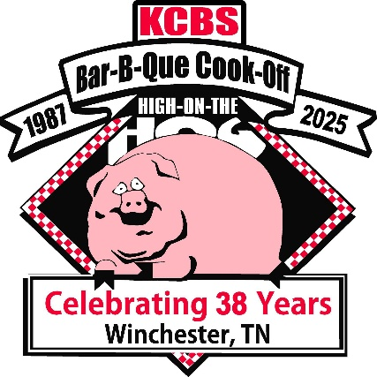
Dear Backyard Barbecue Cook Teams:
The Winchester, Tennessee High on the Hog Festival, The Franklin County Tn. Kiwanis Club, our local sponsors, The City of Winchester, and The Herald Chronicle are inviting you to help us celebrate our 38th year May 16^{h}-17th 2025, your participation is vital to make this the best contest ever. This contest will also be hosting the 11th Annual Trader Bank Backyard BBQ competition. Your participation in the ancillaries would be greatly appreciated, so that we can maintain our relationship with our sponsors in the future.
As you will note on the application the entry fee includes the ALL categories: Chicken and Ribs. There will be optional Pork Category. Creative Sliders contest on Friday Night along with a Wampler’s Creative Taco for this Backyard Contest. On Saturday @ 1:30 PM after turn in there will be Dessert Competition for the backyard teams competing. Meat inspection will begin on Friday morning as teams arrive to the cooking area and hopefully be completed by the time of cooks meeting, which will be a 4 PM in the Citizens pavilion.
Any Team that has won or placed in the top five (5) of any Sanctioned KCBS BBQ Contest, (4 Meat Categories) in the past 2 years Will Not be eligible for the Backyard Division and the Contest Organizer will make the final call on this matter.
The cooking area does provide individual power and water and you will be responsible for hooking up your own power and water. Someone will be on site as you arrive to show you and help you get parked.
NO early arrival as far as setting up, Friday morning is the earliest arrival. Friday and Saturday night entertainment are still to be determined. Also, as in the past several years, the Carnival will be on site.
We are looking forward to the 2025, 38th High on the Hog Festival, Tennessee State Championship.
If there is anything we can do to make your participation a first-class experience, please let us know. Without you, there is no contest.
Nancy Hibler PO Box 461 Winchester, Tn 37398 nancyh927@comcast.net 931-636-2719
Brenda Long brendasuelong@hotmail.com or www.highonthehogfestival.com 931-607-7879

