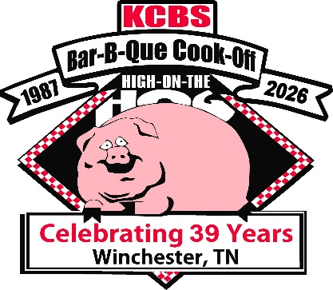39th High on the Hog Festival Backyard Challenge
May 15-16, 2026
$8000 Cash and Prizes Guaranteed
$1200 Grand Champion
$800 Reserve Champion
Places paid thru 10th Place on each category
Contest located at the Winchester City Park, 1561 Phillip Fulmer Pkwy. Winchester Tn 37398
Make checks payable to: Franklin County Kiwanis Club and return to
Nancy Hibler, Backyard Chairman nancyh927@comcast.net 931-636-2719
P.O. Box 461 Winchester Tn 37398
Team Name________________________________________________________________KCBS #______________
Chief Cook ________________________________________________________________ T-Shirt Size ___________________
Address________________________________________________ City____________________________State_______ Zip Code____________
Best Phone Number___________________________________________ Email ______________________________________________________
Space included 20x30 RV/Camper (size)_____________________ Tent Size ________________Cook Trailer Size _________________
Total Team Members____________ Arrival Date___________ Estimated Arrival Time ____________Individual portal John $ 65 _____________
Electricity & water are available. Extra T-shirts are $10 each. Please let us know quantity & sizes:
S________ M________ L________ XL_______ XXL_________ 3XL_______ 4XL________ 5XL__________ OTHER__________
NO THURSDAY ARRIVALS, FRIDAY MORNING THE EARLIEST TO ARRIVE
Entry Fee: $200.00 for All Entries $__________ Paying with PayPal Fee $7.00 $207.00_____________
** Friday Night: **Wampler’s Creative Taco (no dessert tacos) ________ * Creative Sliders _________
** Saturday: Chicken/ Ribs (Grand and Reserve Championship) * Ancillaries (optional) * Pork _______ * Saturday Dessert_________
Total Entry Fee_________
Waiver of Liability: In consideration of the committee accepting this entry, I undersigned intending to be legally bound, hereby, for myself, my Heirs, executors and administrators, waive and release any and all rights and claims for damages I may have against the Winchester Contest Organization, KCBS, their agents, successors and assigns for any and all injuries suffered by me in the event. Further, I hereby grant full permission to the Committee and or agents authorized by them to use photo’s video tapes, motion pictures, recordings or any other record of the event for any legitimate purpose. I agree to abide by the rules and regulations of the High on the Hog Festival and KCBS
Signature of the Chief Cook________________________________________________ Date_____________________

